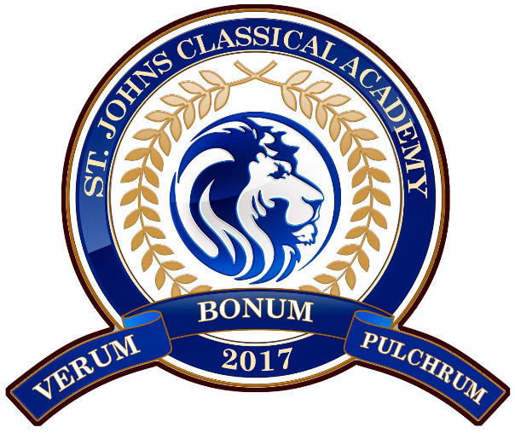

St. Johns Classical Academy
Board of Directors Workshop Agenda
Budget Review & Planning Workshop
Date: January 16, 2026
Time: 12:00 PM – 4:00 PM
Location: 1001 Idlewild Ave, Fleming Island, FL 32043
Campuses: Fleming Island & Orange Park
Lunch: Provided

12:00 – 12:15 PM
Call to Order, Welcome & Workshop Overview
- Call to Order
- Welcome and opening remarks by Chair
- Purpose and goals of the workshop
- Review of agenda
- Initial observations and questions from Board members
- Working lunch begins

12:15 – 1:15 PM
Current Budget Status & Midyear Review (Presented by Ancora)
- Overview of the current year budget
- Midyear financial status and key trends
- Revenue and expenditure highlights
- Campus-level financial overview
- Board questions and discussion

1:15 – 2:15 PM
Budget Considerations (Presented by Ancora)
- Overview of budget pressures and constraints
- Key financial assumptions and risks
- Campus-level financial considerations
- Factors impacting budget balance
- Board discussion

2:15 – 3:00 PM
Campus Leadership Recommendations
- Fleming Island Head of School
  - Campus budget outlook
  - Recommendations for balancing this year’s budget
- Orange Park Head of School
  - Campus budget outlook
  - Recommendations for balancing this year’s budget
- Board questions and discussion

3:00 – 3:40 PM
Budget Alignment & Strategic Options
- Overview of budget alignment considerations
- Review of internal and external recommendations
- Discussion of potential strategies and impacts
- Board input and direction

3:40 – 4:00 PM
Next Steps & Adjournment
- Summary of key takeaways
- Direction to HOS and Ancora
- Timeline for follow-up and future actions
- Adjournment

